**A MINI-PROJECT REPORT ON**

**“Socialgram (A social media app)”**

SUBMITTED TO SAVITRIBAI PHULE PUNE UNIVERSITY, PUNE

IN THE PARTIAL FULFILLMENT OF THE REQUIREMENTS

FOR THE AWARD OF THE DEGREE

**Bachelor of Engineering**

in

**Information Technology**

##### Class: T.E

##### BY

**Name :Gayatri Darshane Roll No./Exam Seat No. :16/T191028516**

**Under the guidance of**

Prof. Suhas Chavan



## DEPARTMENT OF INFORMATION TECHNOLOGY

## RMD SINHGAD SCHOOL OF ENGINEERING

WARJE, PUNE-411058

## A.Y: 2021 - 22



## DEPARTMENT OF INFORMATION TECHNOLOGY

## RMD SINHGAD SCHOOL OF ENGINEERING

WARJE, PUNE-411058

**CERTIFICATE**

This is to certify that the Mini-Project Report entitled

**“MINI-PROJECT TITLE”**

Submitted by

Name:Gayatri Darshane Roll No./Exam Seat No. :16/T191028516

is a bonafide work carried out by him/her under the supervision of Prof. Suhas Chavan and it is submitted towards the partial fulfillment of the requirement for T.E (Information Technology) – 2019 course of Savitribai Phule Pune University, Pune in the academic year 2021-2022

**(Mr. Suhas Chavan)** **(Prof. Sweta Kale)**

Guide Head,

Department of Information Technology Department of Information Technology

(12, Sentence case)

**(Dr. V.V. Dixit)**

Principal,

RMD Sinhgad School of Engineering Pune – 58

Place:

Date:

**ACKNOWLEDGEMENT**

I feel great pleasure in expressing my deepest sense of gratitude and sincere thanks to my guide Mrs. Uma Malusare for their valuable guidance during the Project work, without which it would have been very difficult task. I have no words to express my sincere thanks for valuable guidance, extreme assistance and cooperation extended to all the **Staff Members** of my Department.

This acknowledgement would be incomplete without expressing my special thanks to Ms. Sweta Kale Head of the Department (Information Technology) for their support during the work.

I would also like to extend my heartfelt gratitude to my **Principal Dr. V. V. Dixit** who provided a lot of valuable support, mostly being behind the veils of college bureaucracy.

Last but not least I would like to thanks all the Teaching, Non- Teaching staff members of my department, my parent and my colleagues those who helped me directly or indirectly for completing of this Project successfully.

**NAME OF THE STUDENTS**

Chintan Chaudhari (T-12)

Srushti Dandale (T-15)

Gayatri Darshane (T-16)

Pranit Wankhede (T-79)

**CONTENTS**

|  |  |  |
| --- | --- | --- |
| **Sr.No.** | **Contents** | **Page No.** |
| **1.** | Abstract | **5** |
| **2.** | Introduction | **5** |
| **3.** | Specific requirements  3.1 hardware requirements  3.2 software requirements | **7** |
| **4.** | Implementation details  4.1 Python  4.2 CSS  4.3 HTML  4.4 Django Framework | **7** |
| **5.** | Activity Diagram | **10** |
| **6.** | Working  6.1 Signup  6.2 Login  6.3 Account  6.4 Crud with posts  6.5 Posts  6.6 Logout  6.7 Security | **11** |
| **7** | Conclusion | **14** |
| **8.** | References | **15** |
|  |  |  |

**1.ABSTRACT**

Social media is very important factor in analysing modern society as a whole, their values, norms, and behaviours, as being a part of our everyday life. This social media community is a hub for networkers, marketers, and creatives. A fun way to interact with the world. Get digitally socialised, and sometimes a great platform to advertise your hobbies and business. The explosion of social media is changing the way we communicate, thus affecting the processes involved with information services supporting project management. Social networking sites (SNS) are a way for people in the offline world to stay connected regardless of geographical distance, difference in time, or other context-specific barriers. They are spaces of socialization for common communities, communities in practice, or those united by a shared interest.

**2. INTRODUCTION**

Social media are affecting the way people communicate, develop relationships and build trust in home and work settings. What began as a set of tools for friends to stay connected has evolved into a means for businesses to communicate internally and externally. Although social media channels are used in a variety of contexts, this paper focuses on the emerging trend of its application to support project management. Managing relationships to build trust is especially important for projects managers, because it is becoming increasingly common for project team members to be distributed. This lack of physical contact makes it more difficult to establish strong relationships and bonds that lead to high levels of trust, making the communication process more challenging (Grabner &Kaluscha, 2003). Communications delivered through social media are potentially a valuable resource for developing trust between project team members. Social media is transforming consumer behaviors and business communication patterns. The growth of social media platforms such as Face book and its equivalents have been really rapid. he reasons for the success of online social networks can be found in the work of researchers who studied off-line communities of practice and social networks. Etienne Wenger was one of the pioneers in studying the value that these communities bring to organizations via the strong relationships and social ties that create effective communication and the exchange of knowledge. His research suggests that the power of these communities lies in their ability to develop strong relationships and trust, a prerequisite for effective communications.

**2.1. Problem Statement:**

Distance has made it almost impossible for family members, friends, colleagues etc to connect or communicate very often.

**2.2. Motivation**

**2.3. Objectives:**

* Creating and exchanging content.
* Help people across the world connect easily.
* To make communication easier.
* One can read about trending and important news about hot topics around the globe, news of genres ranging from weather, fashion, health, lifestyle, entertainment, politics, and thus, be informed with the help of social media through social media posts apart from the mainstream media.
* A very important objective of Social Media and that is to Increase the Social Media Community.

**3.SPECIFIC REQUIREMENTS**

**3.1 Hardware requirements:**

* + Network Latency of 200ms or less.
  + Download speed of 1 Mbps or greater.
  + At least 5 GB of RAM

### Software Requirements

* Web Browser.

**4. IMPLEMENTATION DETAILS**

**4.1 PYTHON**:

Python is an interpreted, object-oriented, high-level programming language with dynamic semantics. Its high-level built-in data structures, combined with dynamic typing and dynamic binding, make it very attractive for Rapid Application Development, as well as for use as a scripting or glue language to connect existing components together. Python's simple, easy to learn syntax emphasizes readability and therefore reduces the cost of program maintenance. Python supports modules and packages, which encourages program modularity and code reuse.

The Python interpreter and the extensive standard library are available in source or binary form without charge for all major platforms, and can be freely distributed. Often, programmers fall in love with Python because of the increased productivity it provides. Since there is no compilation step, the edit-test-debug cycle is incredibly fast. Debugging Python programs is easy: a bug or bad input will never cause a segmentation fault. Instead, when the interpreter discovers an error, it raises an exception.

When the program doesn't catch the exception, the interpreter prints a stack trace. A source level debugger allows inspection of local and global variables, evaluation of arbitrary expressions, setting breakpoints, stepping through the code a line at a time, and so on. The debugger is written in Python itself, testifying to Python's introspective power.

**4.2 CSS:**

Cascading Style Sheets (CSS) is a style sheet language used for describing the presentation of a document written in a markup language like HTML.CSS is a cornerstone technology of the World Wide Web, alongside HTML and JavaScript.CSS is designed to enable the separation of presentation and content, including layout, colors, and fonts.This separation can improve content accessibility, provide more flexibility and control in the specification of presentation characteristics, enable multiple web pages to share formatting by specifying the relevant CSS in a separate .css file, and reduce complexity and repetition in the structural content.

CSS information can be provided from various sources. These sources can be the web browser, the user and the author. The information from the author can be further classified into inline, media type, importance, selector specificity, rule order, inheritance and property definition. CSS style information can be in a separate document or it can be embedded into an HTML document. Multiple style sheets can be imported. Different styles can be applied depending on the output device being used; for example, the screen version can be quite different from the printed version, so that authors can tailor the presentation appropriately for each medium.The style sheet with the highest priority controls the content display. Declarations not set in the highest priority source are passed on to a source of lower priority, such as the user agent style. The process is called cascading.

One of the goals of CSS is to allow users greater control over presentation. Someone who finds red italic headings difficult to read may apply a different style sheet. Depending on the browser and the web site, a user may choose from various style sheets provided by the designers, or may remove all added styles and view the site using the browser's default styling, or may override just the red italic heading style without altering other attributes.

**4.3 HTML:**

Hypertext Markup Language (HTML) is the standard markup language for documents designed to be displayed in a web browser. It can be assisted by technologies such as Cascading Style Sheets (CSS) and scripting languages such as JavaScript. Web browsers receive HTML documents from a web server or from local storage and render the documents into multimedia web pages. HTML describes the structure of a web page semantically and originally included cues for the appearance of the document.

HTML elements are the building blocks of HTML pages. With HTML constructs, images and other objects such as interactive forms may be embedded into the rendered page. HTML provides a means to create structured documents by denoting structural semantics for text such as headings, paragraphs, lists, links, quotes and other items. HTML elements are delineated by tags, written using angle brackets. Tags such as <img /> and <input /> directly introduce content into the page. Other tags such as <p> surround and provide information about document text and may include other tags as sub-elements. Browsers do not display the HTML tags, but use them to interpret the content of the page.

HTML can embed programs written in a scripting language such as JavaScript, which affects the behavior and content of web pages. Inclusion of CSS defines the look and layout of content. The World Wide Web Consortium (W3C), former maintainer of the HTML and current maintainer of the CSS standards, has encouraged the use of CSS over explicit presentational HTML since 1997.

**4.4 DJANGO FRAMEWORK:**

Django is a high-level Python web framework that encourages rapid development and clean, pragmatic design. Built by experienced developers, it takes care of much of the hassle of web development, so you can focus on writing your app without needing to reinvent the wheel. It’s free and open source. Django was designed to help developers take applications from concept to completion as quickly as possible.

Django takes security seriously and helps developers avoid many common security mistakes. Some of the busiest sites on the web leverage Django’s ability to quickly and flexibly scale. Django was initially developed between 2003 and 2005 by a web team who were responsible for creating and maintaining newspaper websites. After creating a number of web sites, the team began to factor out and reuse lots of common code and design patterns. This common code evolved into a generic web development framework, which was open-sourced as the “Django” project in July 2005.

**5. ACTIVITY DIAGRAM:**

Create account

(Signup)

Log into your account

Check permission

Check permission

Check permission

Check permission

Check permission

Manage users

Edit personal information

Manage photos

Manage posts

Log out of the system

**6. WORKING:**

**SOCIALGRAM FRONTEND:**

This is what the Frontend or the GUI of the project SOCIALGRAM looks like. Here you have various options to explore such as sign in, log in, view posts, search bar etc.

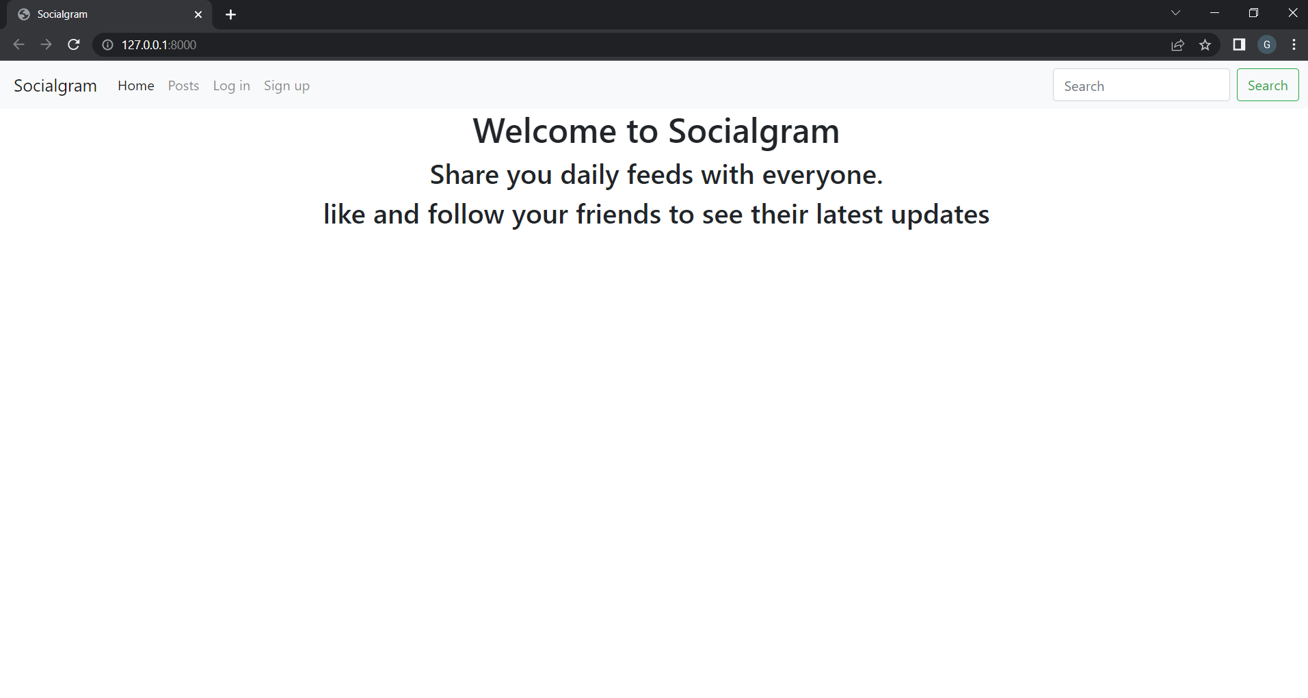

**6.1.SIGN-UP:**

To be able to use this social media application, one needs to first create an account on it and then for more conveniency of the user, anytime one wants to open his or her account, be it on the same device or on a different device, the user can log in directly.

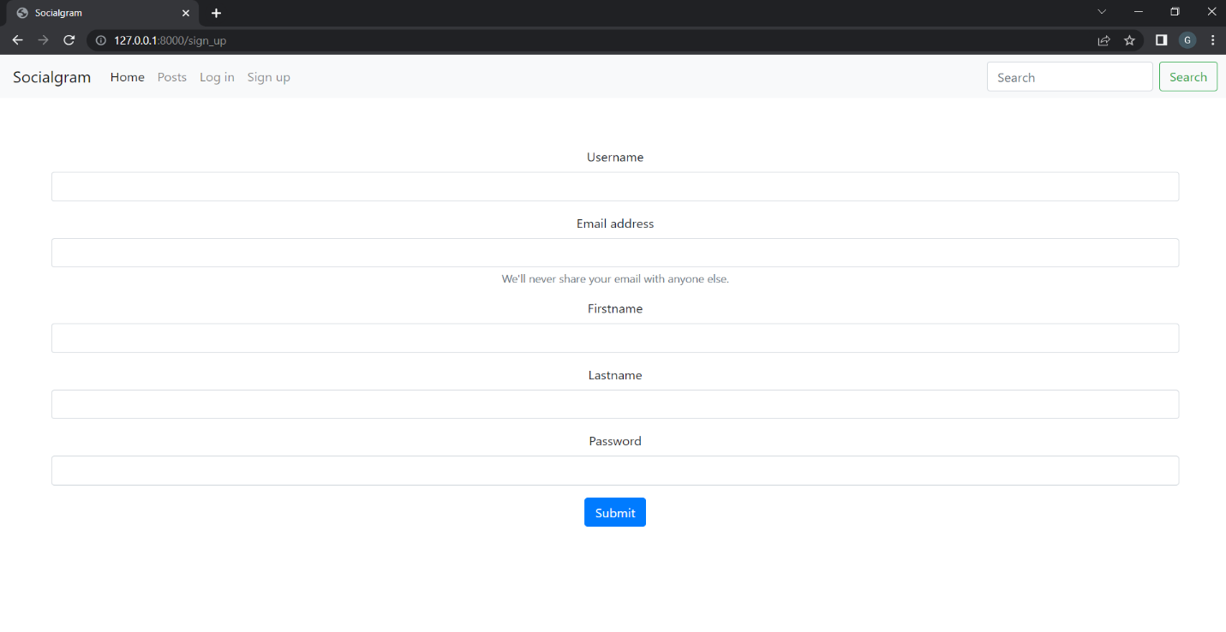

**6.2.LOG-IN:**

While logging into your account the user needs to enter the username (entered while creating an account) and password (entered while creating an account). The user can easily login into multiple devices simultaneously with the account username and password. Incorrect password will not lead the user to his /her account.

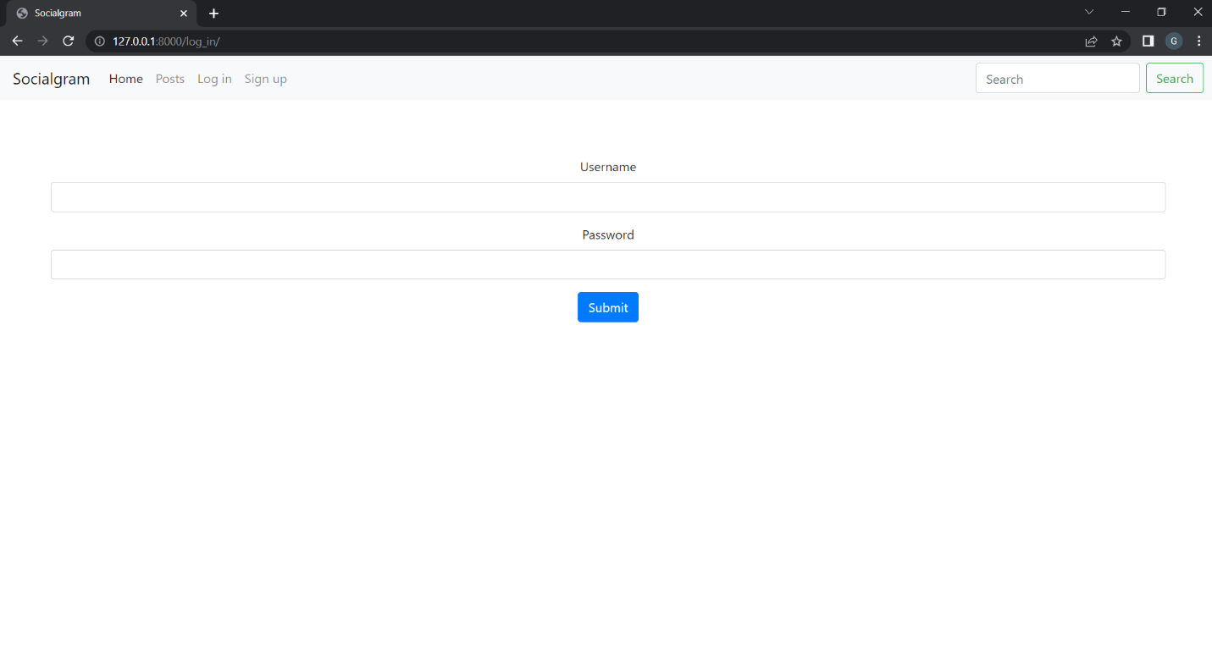

**6.3.ACCOUNT:**

The account section is where the user can have the insights of their account. The user can edit their personal information here and also if they wish to they can delete a post from their account from among the posted posts.

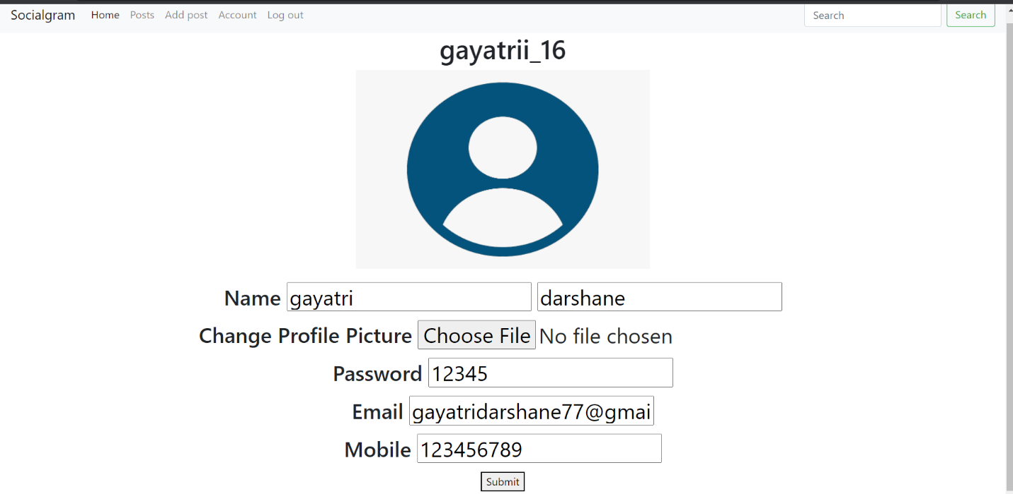

**6.4.CRUD WITH POSTS:**

In the add posts section which will open only after the user logs in into their account, the user can then add a picture that they have been wanting to post. Clicking on the ‘choose file’ button will allow the user to choose the picture they want to upload from their device and the ‘write description’ box will allow the user to add a caption to the picture that the user is wanting to post.

Similarly, it is possible to Update and Delete the post created by the user.

**6.5.POSTS:**

This section consists of social media images that the user has posted. The user can have a look at all their posts by entering the ‘posts’ section.

**6.6. LOG OUT:**

Loging out means to end the access to a computer system or a website. Loging out informs the computer or website that the current user wishes to end the login session. Loging out helps prevent the other users from accessing the system without verifying their credentials. It also helps protect the current users access or prevent unauthorized actions on the current login session and is thus an important part of security. Log out is also known as log off, sign off or sign out.

**6.7. SECURITY:**

We are using ‘Session Keys’ to keep user Logged in and authenticate the user on every necessary route. Without session keys no user has permission to access or make changes in the account or on the website.

**7. Conclusion:**

Social media’s big draw is that it is a quick and easy way to connect with friends and loved ones. You can share exciting news about your life through statuses, pictures and videos. Social media platforms allow users to have conversations, share information, and create web content. Social media has plenty of good uses as it allows stories or events that began locally to gain a global or worldwide attention. This allows to become an amazing platform to make world connect and spread information faster than ever in the history of mankind.

It is one of the best ways to stay inform about the current events, increase marketing exposure and stay connected with family and friends over miles of distance. Theis global phenomenon of technology spreading worldwide makes it easy for people to communicate faster and easily promote their business to massive amount of people in short time and in a very inexpensive way. Social media might have disadvantages, but it has more advantages especially can be useful to humans in accessing information.

**8.References:**

<https://www.google.com/>

<https://www.wikipedia.org/>